TRANSFER AGREEMENT

4-Year Institution: | Bachelor’s Degree Program: | Academic Year:
Nevada State University (NS) | BA - Elementary Education with a  concentration in Special Education | 2025-2026
2-Year Transfer Institution:
 | Associate’s Degree Program: | Emphasis:
Truckee Meadows Community  College (TMCC) | Associate of Arts | Elementary Education  Teacher Preparation
NOTE: This transfer agreement has been created specifically for the programs listed above and only applies to students that complete the associate’s degree listed. If the associate’s degree is not earned, or a new program is selected, the transfer and articulation of listed courses, as well as fulfilled degree requirements, could be impacted.

- Students should complete the Associate of Arts in Elementary Education Teacher Preparation at TMCC and the coordinated program of study for the Bachelor of Arts in Elementary Education with a concentration in Special Education at NS as indicated in this transfer guide. Any course substitutions should be made with the guidance of an advisor or counselor to assure that all requirements are met.
- Transfer Rights and Responsibilities

- Only courses with a grade of D or higher will be accepted for transfer to NS. However, only courses with a grade of C- or higher (equivalent to 1.7 grade points for each credit earned) can carry credit towards major requirements. A course completed with a grade of less than C-, if counted toward graduation at the community college, may be used to satisfy NS graduation requirements. However, the course will have to be repeated if the NS major specifies a higher grade for all students. If a TMCC course has more credits than the NS equivalent course, the additional credits will be included in the program total as general transfer credit. NS requires that a minimum of 60 credits must be completed at the four-year institution. Additionally, a minimum of 32 upper division credit hours must be completed in residence at Nevada State University.

- Students may elect to graduate under the course catalog graduation requirements under any of the following options, provided that the course catalog at the time of graduation is not more than 10 years old:

  - The course catalog of the year of enrollment in a baccalaureate level course/program at a NSHE community college (a valid transfer agreement may be required).

  - The course catalog of the year of transfer into a baccalaureate level program at the universities, state college, or community colleges that offer select baccalaureate degrees.

  - The course catalog of the year of graduation from a NSHE institution

Bachelor’s Required General Education/Core Courses: General education/core courses are to be completed during the associate’s program. NOTE: Lower-division General Education requirements are fulfilled upon completion of the associate’s degree, with the exception of the courses listed below. If a General Education subject is not listed here, you may select any general education course approved for the associate’s degree program.

ENG 101, ENG 102, MATH 120, FINE ARTS, HUMANITIES, SOCIAL SCIENCE, U.S. and Nevada Constitution, Sciences (1w/lab), Cultural Diversity, EDU 201
Specific Program Courses: The following courses also should be completed during the associate’s program. These courses will articulate to specific program requirements for the bachelor’s program. Courses marked with an asterisk (*) are critical prerequisite or bachelor’s program progression courses which will impact a student’s progress to completing the bachelor’s degree in a timely manner if they are not taken during the associate’s degree program.

PSY 233, EDU 203, EDU 206, EDU 207, MATH 122, MATH 123, EDU 214, HDFS 201, EDU 208

Articulations/Block Transfer: The following are approved articulations/substitutions/block transfer for the above mentioned programs. These courses will transfer accordingly and apply to the bachelor’s program as listed.
Associate’s Program Course | Bachelor’s Program Course | Bachelor’s Requirement
ENG 101 (3) | ENG 101 (3) | CORE
MATH 120 (3) OR HIGHER | MATH 120 (3) | CORE
FINE ARTS (3) | FINE ARTS (3) | CORE
SOCIAL SCIENCE (3) | SOCIAL SCIENCE (3) | CORE
PSY 233 (3) | PSY 330 (3) | MAJOR
ENG 102 (3) | ENG 102 (3) | CORE
SCIENCE (3) | SCIENCE (3) | CORE
HUMANITIES (3) | HUMANITIES (3) | CORE
EDU 201 (3) | HUMANITIES (EDU 250) (3) | CORE
US/NV CONSTITUTIONS (3) | US/NV CONSTITUTIONS (3) | CORE
EDU 203 (3) | EDU 203 (3) | MAJOR
SCIENCE W/ LAB (4) | SCIENCE W/ LAB (3) | CORE
EDU 206 (3) | EDU 206 (3) | MAJOR
EPY 220a | EDU 220 | MAJOR
MATH 122 (3) | MATH 122 (3) | MAJOR
MATH 123 (3) | MATH 123 (3) | MAJOR
EDU 214 (3) | EDU 214 (3) | MAJOR
HDFS 201 (3) | PSY 330 (3) or EDSP 432 (3) | MAJOR
EDU 208 (3) | EDSP 441 (3) | MAJOR
EMPHASIS REQUIREMENT (3) | ELECTIVE (3) | ELECTIVE

Program Notes: Total Transfer Credits 60

Year-to-Year Course Outline
Associate’s Program Year 1 | Associate’s Program Year 2 | BACHELOR’S PROGRAM YEAR 3 | BACHELOR’S PROGRAM YEAR 4 | BACHELOR’S PROGRAM YEAR 5
ENG 101 (3) | EDU 203 (3) | EDRL 435 (3) | EDEL 433 (3) | EDEL 493 (9)
MATH 120 (3) OR HIGHER | SCIENCE W/ LAB (3-4) | EDRL 471 (3) | EDRL 437 (3) | EDU 283 (3)
FINE ARTS (3) | EDU 206 (3) | EDSP 432 (3) | EDSP 431 (3)
SOCIAL SCIENCE (3) | EPY 220A (3) | EDSP 455 (3) | EDSP 452 (3)
PSY 233 (3) | MATH 122 (3) | EDSP 443 (3) | EDSP 453 (3)
ENG 102 (3) | MATH 123 (3) | EDRL 474 (3) | EDRL 461 (3)
SCIENCE (3) | EDU 214 (3) | EDSP 464 (3) | EDEL 453 (3)
HUMANITIES (3) | HDFS 201 (3) | EDSP 441 (3) | EDEL 443 (3)
EDU 201 (3) | EDU 208 (3) | EDRL 477 (3) | EDSP 414 (3)
US/NV CONSTITUTIONS (3) | ANY EMPHASIS REQUIREMENT (3) | EDRL 475 (3) | EDRL 457 (3)
CREDITS: 30 | CREDITS: 30-31 | Credits: 24-30 | Credits: 30 | Credits: 12

*Program admission required

Consult advisor for course sequencing. Some courses may only be offered during a certain semester.
TEACHER PREPARATION PROGRAM

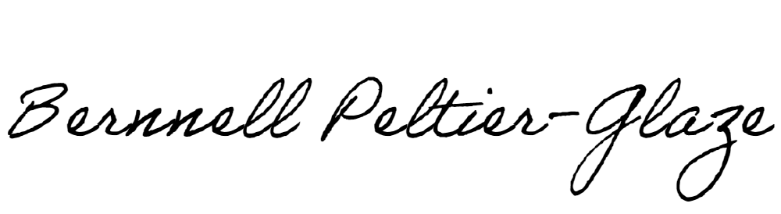Nevada State University Truckee Meadows Community College Recommended By:

Name: Bernnell Peltier-Glaze Title: Dean of School of Education Date: _2/11/2025
Name: Title: Date:

Approved by:

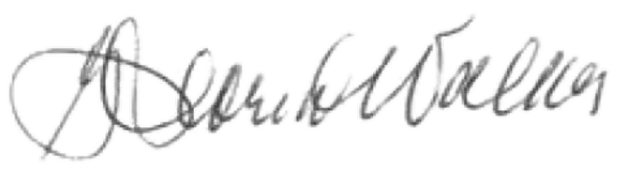
By: Name: Gloria J. Walker Title: VP of Finance and Business Operations Date:

