TRANSFER AGREEMENT

4-Year Institution: | Bachelor’s Degree Program: | Academic Year:
Nevada State University (NS) | BA - Secondary Education with a  concentration in English | 2025-2026
2-Year Transfer Institution:
 | Associate’s Degree Program: | Emphasis:
Truckee Meadows Community  College (TMCC) | Associate of Arts | Secondary Education
NOTE: This transfer agreement has been created specifically for the programs listed above and only applies to students that complete the associate’s degree listed. If the associate’s degree is not earned, or a new program is selected, the transfer and articulation of listed courses, as well as fulfilled degree requirements, could be impacted.

- Students should complete the Associate of Arts in Secondary Education at TMCC and the coordinated program of study for the Bachelor of Arts in Secondary Education with a concentration in English at NS as indicated in this transfer guide. Any course substitutions should be made with the guidance of an advisor or counselor to assure that all requirements are met.
- Transfer Rights and Responsibilities

- Only courses with a grade of D or higher will be accepted for transfer to NS. However, only courses with a grade of C- or higher (equivalent to 1.7 grade points for each credit earned) can carry credit towards major requirements. A course completed with a grade of less than C-, if counted toward graduation at the community college, may be used to satisfy NS graduation requirements. However, the course will have to be repeated if the NS major specifies a higher grade for all students. If a TMCC course has more credits than the NS equivalent course, the additional credits will be included in the program total as general transfer credit. NS requires that a minimum of 60 credits must be completed at the four-year institution. Additionally, a minimum of 32 upper division credit hours must be completed in residence at Nevada State University.

- Students may elect to graduate under the course catalog graduation requirements under any of the following options, provided that the course catalog at the time of graduation is not more than 10 years old:

  - The course catalog of the year of enrollment in a baccalaureate level course/program at a NSHE community college (a valid transfer agreement may be required).

  - The course catalog of the year of transfer into a baccalaureate level program at the universities, state college, or community colleges that offer select baccalaureate degrees.

  - The course catalog of the year of graduation from a NSHE institution

Bachelor’s Required General Education/Core Courses: General education/core courses are to be completed during the associate’s program. NOTE: Lower-division General Education requirements are fulfilled upon completion of the associate’s degree, with the

exception of the courses listed below. If a General Education subject is not listed here, you may select any general education course approved for the associate’s degree program.

ENG 101, ENG 102, MATH 120, HUMANITIES, EDU 201, SOCIAL SCIENCE, U.S. and Nevada Constitution, Cultural Diversity
Specific Program Courses: The following courses also should be completed during the associate’s program. These courses will articulate to specific program requirements for the bachelor’s program. Courses marked with an asterisk (*) are critical prerequisite or bachelor’s program progression courses which will impact a student’s progress to completing the bachelor’s degree in a timely manner if they are not taken during the associate’s degree program.

COM 250, ENG 231, PSY 233, ENG 281, EDU 203, ENG 235, ENG 205, EDU 214, ENG 298, ENG 241

Articulations/Block Transfer: The following are approved articulations/substitutions/block transfer for the above mentioned programs. These courses will transfer accordingly and apply to the bachelor’s program as listed.
Associate’s Program Course | Bachelor’s Program Course | Bachelor’s Requirement
EDU 202 (3) | EDU 250 (3) (HUMANITIES) | CORE
ENG 101 (3) | ENG 101 (3) | CORE
ENG 202 (3) (FINE ARTS) | FINE ARTS (3) | CORE
FOREIGN LANGUAGE (3) (REPLACE W/ JOUR 107) | COM 250 (3) | MAJOR
ENG 102 (3) | ENG 102 (3) | CORE
FOREIGN LANGUAGE (3) (REPLACE W/ ENG 231) | ENG 231 (3) (ENG-SURVEY) | MAJOR
CH 201 OR CH 202 (3)  (HUMANITIES) | HUMANITIES (3) | CORE
MATH 120 (3) OR HIGHER | MATH 120 (3) | CORE
PSY 233 (3) | EDU 220 (3) | MAJOR
ENG 281 (3) | ENG 211 (2) | MAJOR
EDU 203 (3) | EDSP 411 (3) | MAJOR
ENG LD (3) | ENG 235 (3)  (ANCIENT- RENAISSANCE LITERATURE) | MAJOR
FOREIGN LANGUAGE (3) (REPLACE W/ ENG 232) | ENG 232 (3)  ( 17th-19th Century Literature) | MAJOR
SCIENCE (ENV 101) (3) | SCIENCE (3) | CORE
COM 113 (3)  (SOCIAL SCIENCE) | SOCIAL SCIENCE (3) | CORE
EDU 214 (3) | EDU 214 (3) | MAJOR
ENG 298 (3) | ENG 298 (3) | MAJOR
FOREIGN LANGUAGE (3) | ENG (3) | MAJOR
SCIENCE W/ LAB (3-4) | SCIENCE W/ LAB (3) | CORE
US/NV CONSTITUTIONS (3)  (CH 203 RECOMMENDED) | US/NV CONSTITUTIONS (CH 203) (3) | CORE
*Diversity: Refer to TMCC Diversity list and Academic Advising

Program Notes: Total Transfer Credits 60

Year-to-Year Course Outline
Associate’s Program Year 1 | Associate’s Program Year 2 | BACHELOR’S PROGRAM YEAR 3 | BACHELOR’S PROGRAM YEAR 4 | BACHELOR’S PROGRAM YEAR 5
EDU 202 (3) | EDU 203 (3) | ENG-TOPICS (3) UD | ENG 411B (3) | EDSC 483 (9)
ENG 101 (3) | ENG 235 (3) | EDRL 471 (3) | ENG-TOPICS (3)  ENG 497A RECOMMENDED | EDU 283 (3)
FINE ARTS (3)  (ENG 202 RECOMMENDED) | FOREIGN LANGUAGE  (3) (REPLACE W/ ENG 232) | EDSP 432 (3) | EDRL 477 (3)
FOREIGN LANGUAGE (3) (REPLACE W/ JOUR 107) | SCIENCE (ENV 101)  (3) | ENG-HISTORY (20TH & 21ST CENTURY LIT) (3) | EDSC 433 (3)
ENG 102 (3) | SOCIAL SCIENCE (3)  (COM 113 RECOMMENDED) | ENG-HISTORY (17- 19th CENTURY LIT) (3) (UPPER DIVISION) | ENG 326 Junior Seminar
FOREIGN LANGUAGE (3)  (REPLACE W/ ENG 231) | EDU 214 (3) | EDSC 325 (3) | ENG 401A (3)
HUMANITIES (3)  (CH 201 OR 202) | ENG 298 (3) | ENG-UD | ENG- Renaissance Lit  (3) UD
MATH 120 (3) OR HIGHER | FOREIGN LANGUAGE  (3) (REPLACE W/ ENG ) | EDRL 474 (3) | EDU 280
PSY 233 (3) | SCIENCE W/ LAB (3-4) | ELECTIVE (3) | ENG-TOPICS (3)  ENG 427A RECOMMENDED
ENG 281 (3) | US/NV CONSTITUTIONS (3)  (CH 203 RECOMMENDED) | ENG 303 (3) | EDRL 475 (3)
CREDITS: 30 | CREDITS: 30-31 | Credits: 24-30 | Credits: 24-30 | Credits: 12

*Program admission required

- EDU 163 and EDU 164 are required for students who do not have passing Praxis I scores.
EDU 163: The Praxis Core Literacy Lab will be waived for students who produce passing scores for both the reading and writing exams.

EDU 164: The Praxis Core Mathematics Lab will be waived for students who produce a passing score for the mathematics exam.
- Consult advisor for course sequencing. Some courses may only be offered during a certain semester.

TEACHER PREPARATION PROGRAM

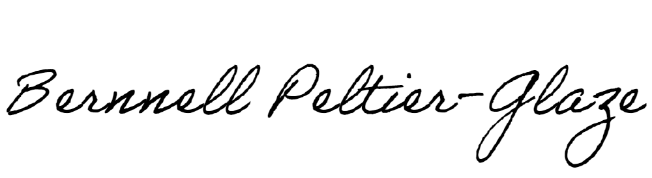Nevada State University Truckee Meadows Community College Recommended By:

Name: Bernnell Peltier-Glaze Title: Dean of School of Education Date: _2/11/2025
Name: Title: Date:

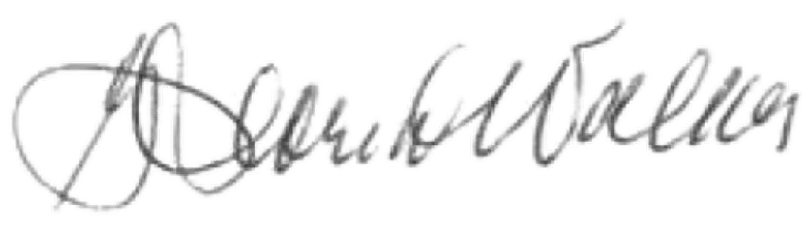
Approved by:

By: Name: Gloria J. Walker Title: VP of Finance and Business Operations Date:

