TRANSFER AGREEMENT

4-Year Institution: | Bachelor’s Degree Program: |  | Academic Year:
Nevada State University (NSU) | BA - Elementary Education |  | 2025-2026
2-Year Transfer Institution: | Associate’s Degree Program:
 | Associate’s Degree Program: |  | Emphasis:
Western Nevada College (WNC) | Associate of Arts
NOTE: This transfer agreement has been created specifically for the programs listed above and only applies to students that complete the associate’s degree listed. If the associate’s degree is not earned, or a new program is selected, the transfer and articulation of listed courses, as well as fulfilled degree requirements, could be impacted.

- Students should complete the Associate of Arts at WNC and the coordinated program of study for the Bachelor of Arts in Elementary Education at NSU as indicated in this transfer guide. Any course substitutions should be made with the guidance of an advisor or counselor to ensure that all requirements are met.

- Transfer Rights and Responsibilities

- Only courses with a grade of D or higher will be accepted for transfer to NSU. However, only courses with a grade of C- or higher (equivalent to 1.7 grade points for each credit earned) can carry credit towards major requirements. A course completed with a grade of less than C-, if counted toward graduation at the community college, may be used to satisfy NSU graduation requirements. However, the course will have to be repeated if the NSU major specifies a higher grade for all students. If a WNC course has more credits than the NSU equivalent course, the additional credits will be included in the program total as general transfer credit. NSU requires that a minimum of 60 credits must be completed at the four-year institution. Additionally, a minimum of 32 upper division credit hours must be completed in residence at Nevada State University.

- Students may elect to graduate under the course catalog graduation requirements under any of the following options, provided that the course catalog at the time of graduation is not more than 10 years old.

  - The course catalog of the year of enrollment in a baccalaureate level course/program at a NSHE community college (a valid transfer agreement may be required).

  - The course catalog of the year of transfer into a baccalaureate level program at the universities, state college, or community colleges that offer select baccalaureate degrees.

  - The course catalog of the year of graduation from a NSHE institution.

Bachelor’s Required General Education/Core Courses: General education/core courses are to be completed during the associate’s program. NOTE: Lower-division General Education requirements are fulfilled upon completion of the associate’s degree, with the exception of the courses listed below. If a General Education subject is not listed here, you may select any general education course approved for the associate’s degree program.
ENG 101, ENG 102, COM 101, PSC 101, GEOG 103, FINE ARTS, WORLD LANGUAGE, BIOL 101, SOCIAL SCIENCE, EDU
201,
Specific Program Courses: The following courses also should be completed during the associate’s program. These courses will articulate to specific program requirements for the bachelor’s program. Courses marked with an asterisk (*) are critical prerequisite or bachelor’s program progression courses which will impact a student’s progress to completing the bachelor’s degree in a timely manner if they are not taken during the associate’s degree program.

EDU 203, EDU 214, EDU 220, MATH 122, MATH 123

Articulations/Block Transfer: The following are approved articulations/substitutions/block transfer for the above mentioned programs. These courses will transfer accordingly and apply to the bachelor’s program as listed.

Associate’s Program Course | Bachelor’s Program Course | Bachelor’s Requirement
ENG 101 | ENG 101 | CORE
ENG 102 | ENG 102 | CORE
MATH 120 | MATH 120 | CORE
HUMANITIES | HUMANITIES | CORE
US/NV CONSTITUTIONS | US/NV CONSTITUTIONS | CORE
FINE ARTS | FINE ARTS | CORE
EDU 201 | EDU 250 (HUMANITIES CORE) | CORE
SOCIAL SCIENCE | SOCIAL SCIENCE | CORE
SCIENCE | SCIENCE | CORE
SCIENCE W/LAB | SCIENCE W/LAB | CORE
LIBERAL ARTS REQ | LIBERAL ARTS | CORE
LIBERAL ARTS REQ (PSY 233 RECOMMENDED) | PSY 330 | MAJOR
EDU 203 | EDU 203 | MAJOR
EDU 214 | EDU 214 | MAJOR
PSY 220/EDU 220 | EDU 220 | MAJOR
MATH 122 | MATH 122 | MAJOR
MATH 123 | MATH 123 | MAJOR
EDU 206 | EDU 206 | MAJOR
EDU 207 | EDU 215 | MAJOR
ELECTIVE | ELECTIVE | ELECTIVE
Program Notes: Total Transfer Credits 60

ASSOCIATE’S PROGRAM YEAR 1 | ASSOCIATE’S PROGRAM YEAR 2 | BACHELOR’S PROGRAM YEAR 3 | BACHELOR’S PROGRAM YEAR 4 | BACHELOR’S PROGRAM YEAR 5
MATH 120 | EDU 214 | EDRL 474 | EDEL 442* | EDEL 483 (9)
ENG 101 | SCIENCE W/LAB | EDRL 471 | EDEL 443 * | EDU 283 (3)
HUMANITIES | US/NV CONSTITUTIONS | EDSP 432 | EDRL 455*
EDU 201 | MATH 122 | EDRL 475 | EDRL 477 *
FINE ARTS | LIBERAL ARTS REQUIREMENT  PSY 233 RECOMMENDED | EDSP 464 | EDEL 453 *
ENG 102 | EDU 206 | EDU 280 | EDEL 433 *
SCIENCE | MATH 123 | EDRL 435 * | EDRL 457*
SOCIAL SCIENCE | EDU 207 | EDEL 452 * | EDRL 437*
LIBERAL ARTS REQUIREMENT | PSY 220
ELECTIVE | EDU 203
CREDITS: 29 | CREDITS: 31 | CREDITS: 24 | CREDITS: 24 | CREDITS: 12

*Program admission required

TEACHER PREPARATION PROGRAM

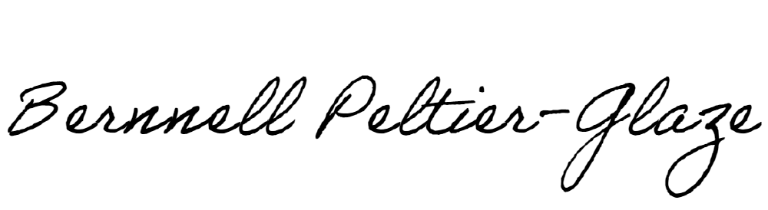Nevada State University Truckee Meadows Community College Recommended By:

Name: Bernnell Peltier-Glaze Title: Dean of School of Education Date: _2/11/2024
Name: Title: Date:

Approved by:

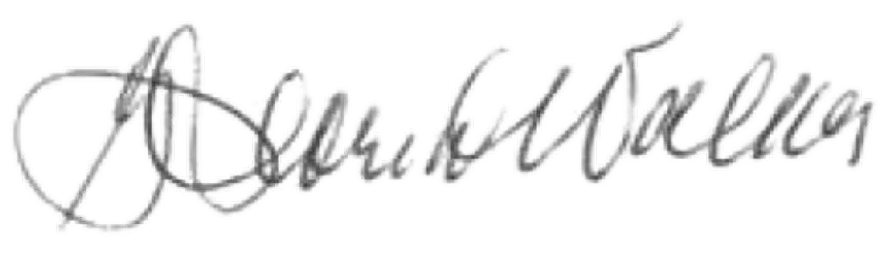
By: Name: Gloria J. Walker Title: VP of Finance and Business Operations Date:

